**Spring Boot Application CI Pipeline**

Step-1: Creating Spring Boot Project

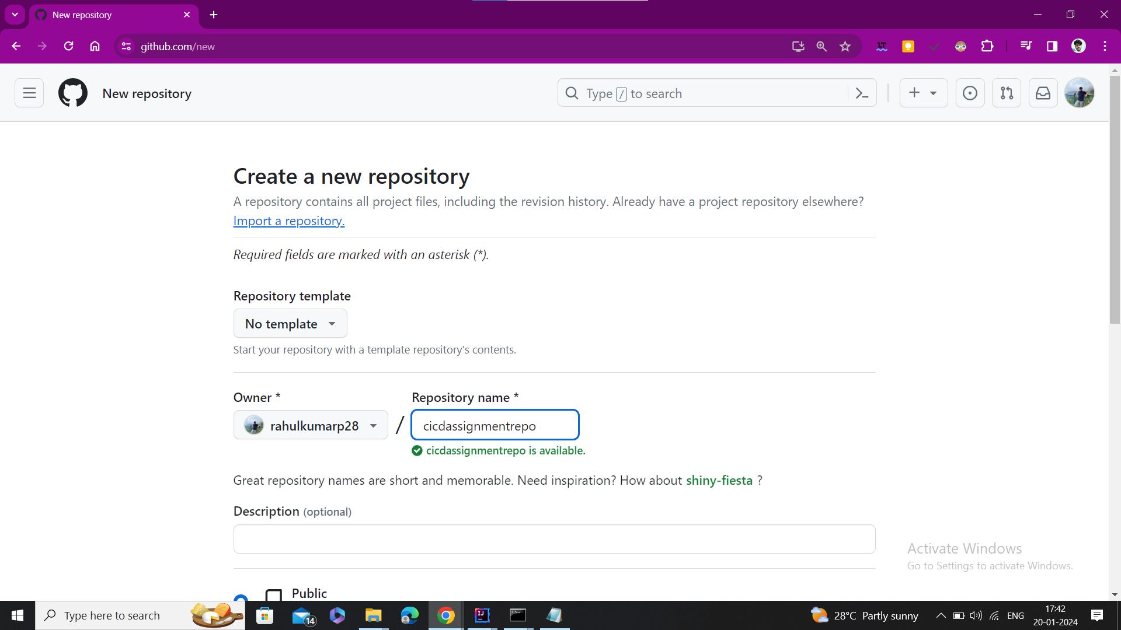Step-2: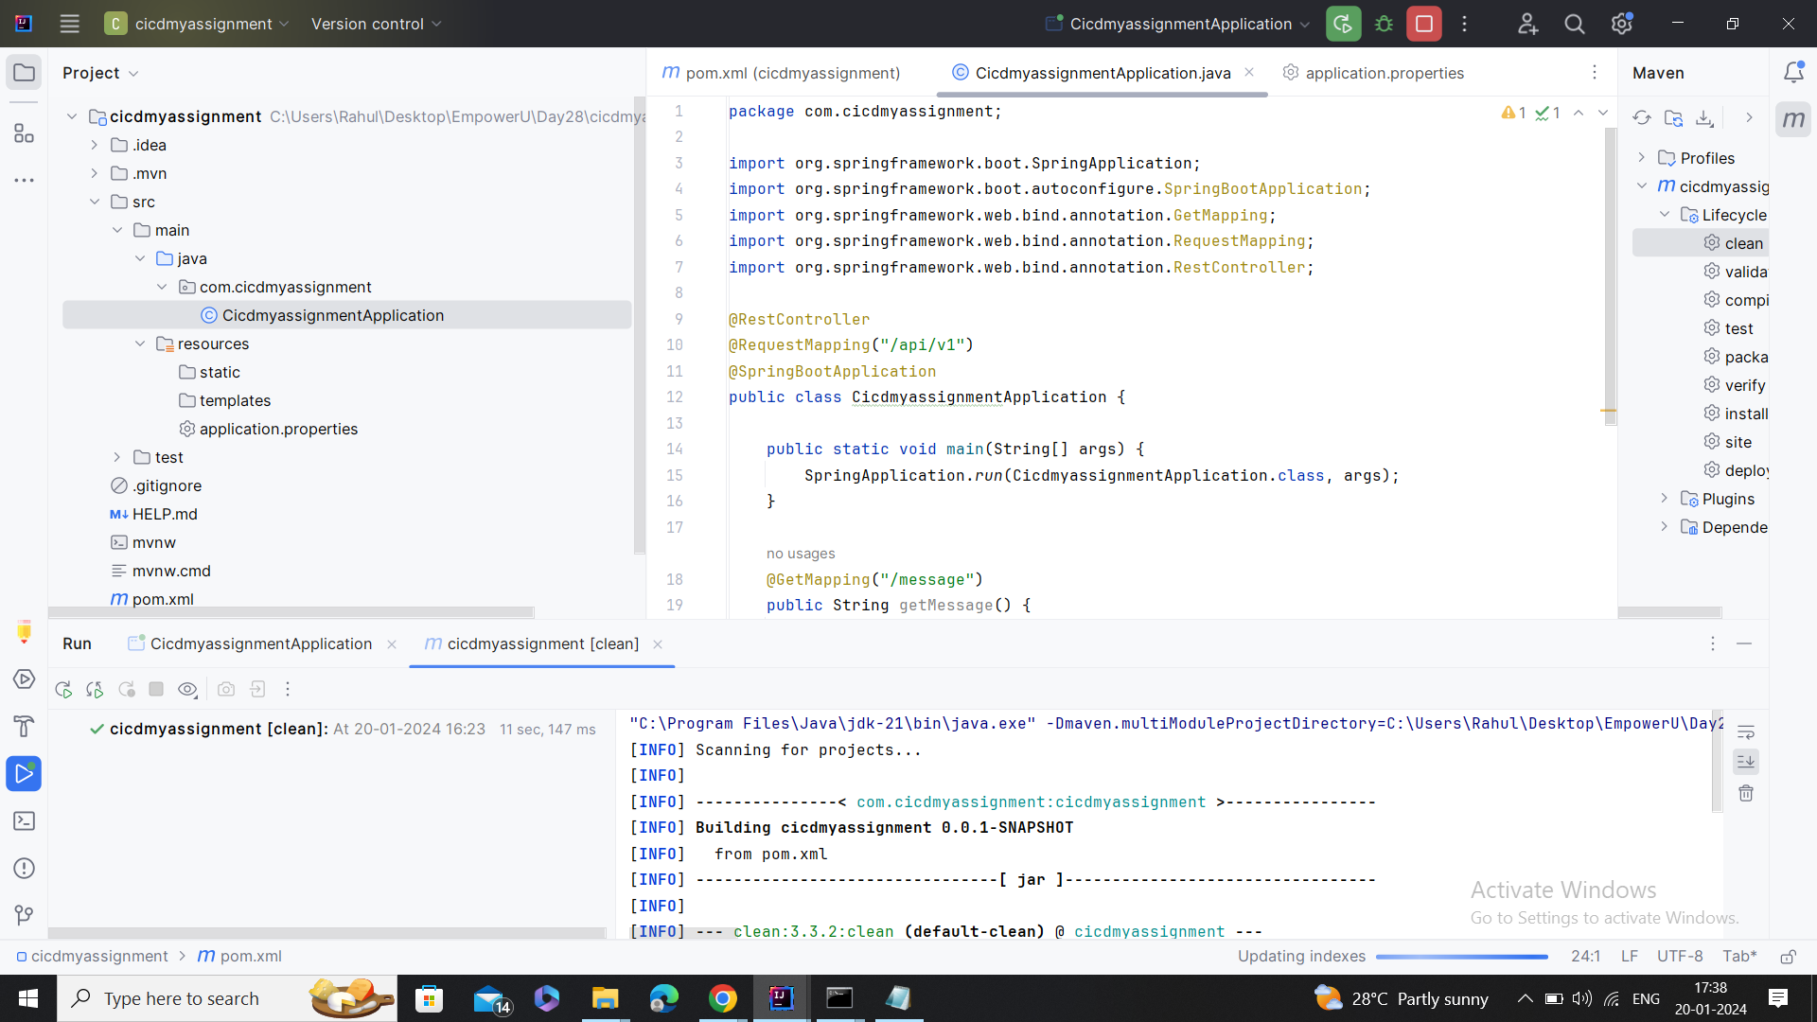 Creating New Github Repository

Step-3: Setting yml file

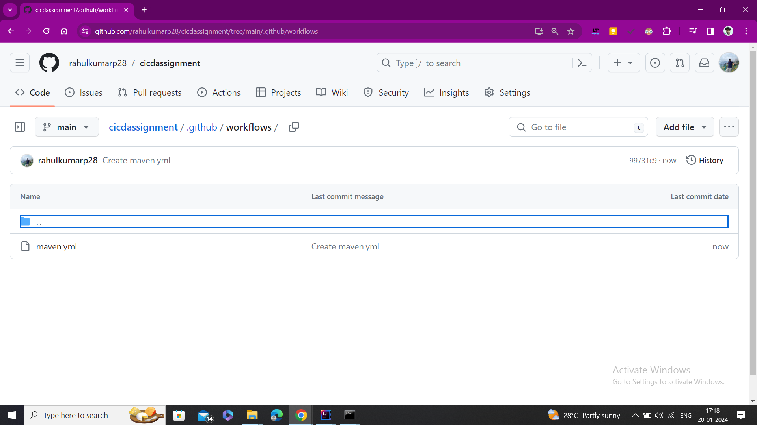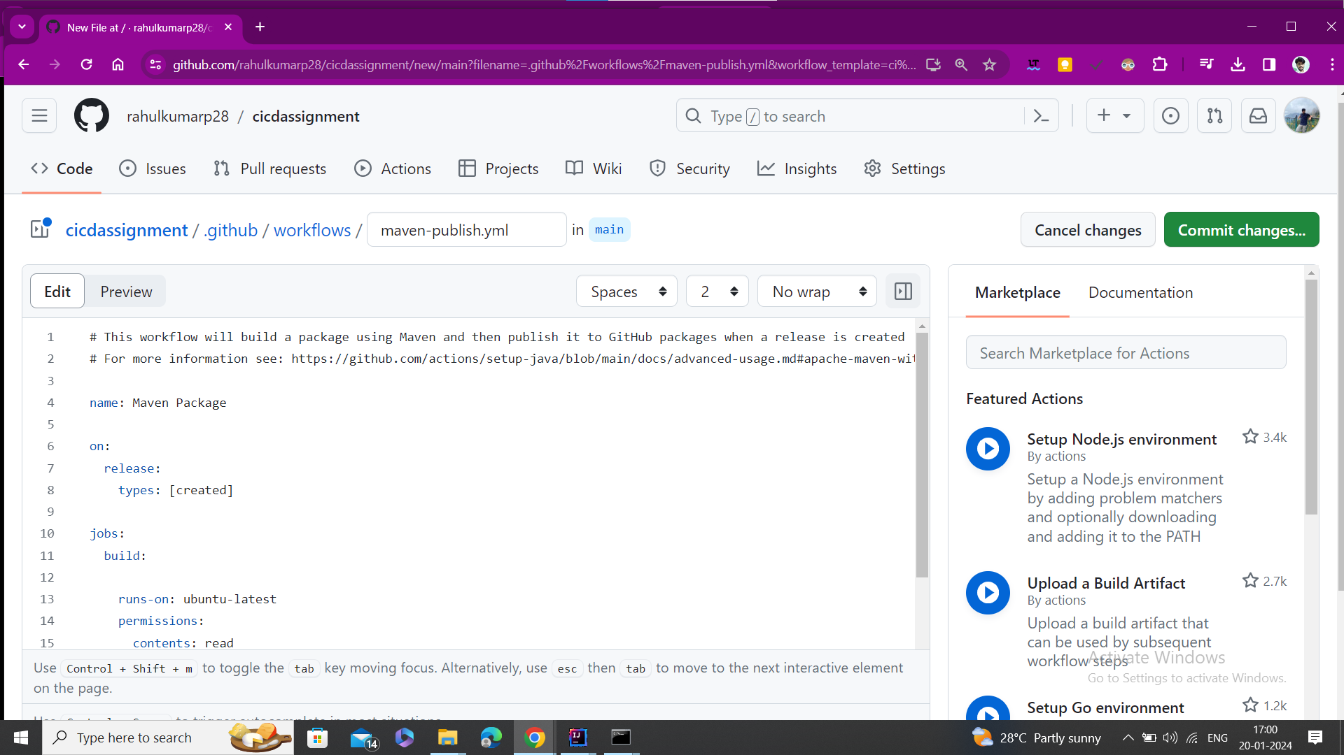Step-4: Maven file created

Step-5: Building Maven

